# Configuring Web Pages on local Machine

1. Open the git repository “pg-web” <https://github.com/jainsuy/pg-web> in web browser
2. Click on Clone or download button & select download zip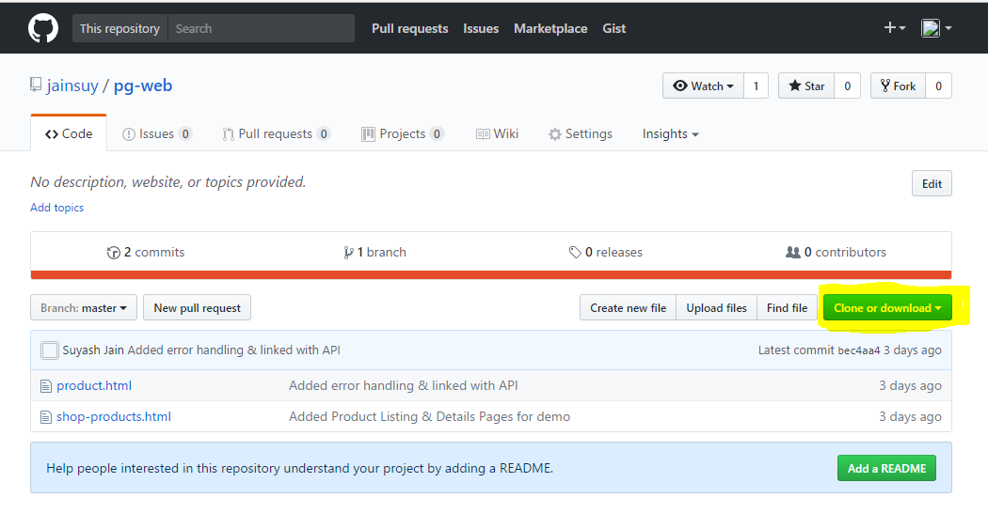
3. Unzip the file in location of your choice. You should have following html pages in extracted folder: -
   1. shop-products.html
   2. product.html
   3. orders.html

## Product Listing page (shop-products.html)

Product listing page display list of available product by making call to Product Master API that you configured in earlier exercise. To configure this page follow below steps: -

1. Open ***shop-products.html*** in Notepad++ / Visual Studio
2. Search for “***var productCMSServiceUrl***”. You will find variable declaration as shown in below image: - 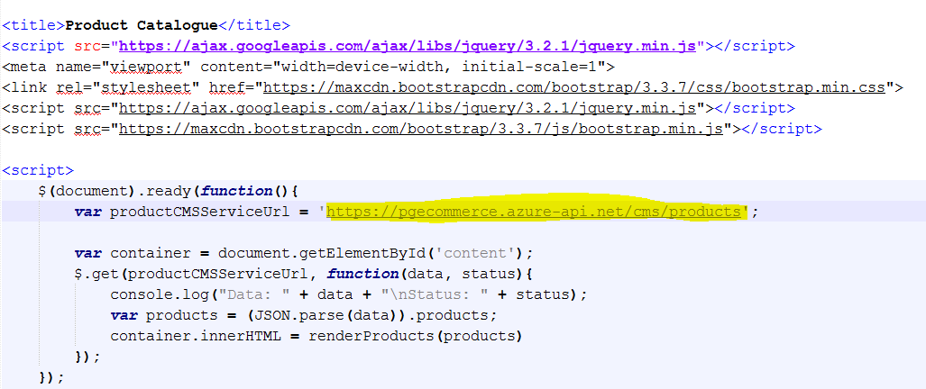
3. Change URL to Product Master API that you configured in earlier exercise & save changes
4. Now open html page in Web Browser. You should see product catalog page with list of products

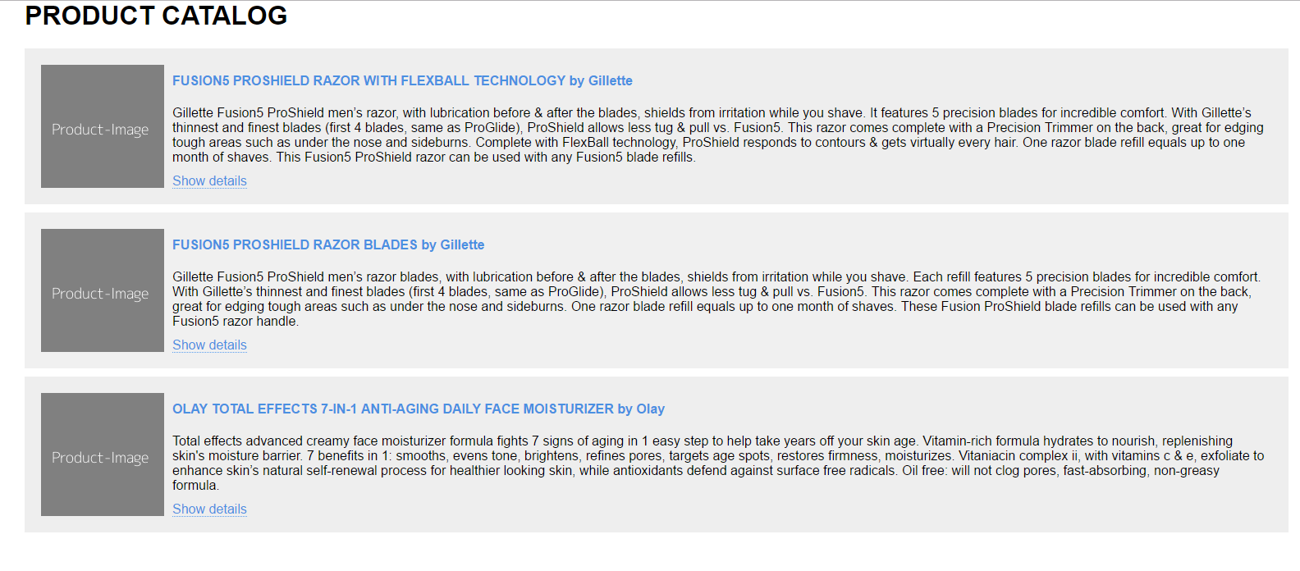

## product details page

Product details page makes use of pgecommerce aggregated service /API to show product basic information, image, review statistics & reviews if available. Steps to config this page as following: -

1. Open ***product.html*** page in Notepad++ / Visual Studio
2. Search for “var productServiceUrl”. You will find variable declaration as shown in below image: -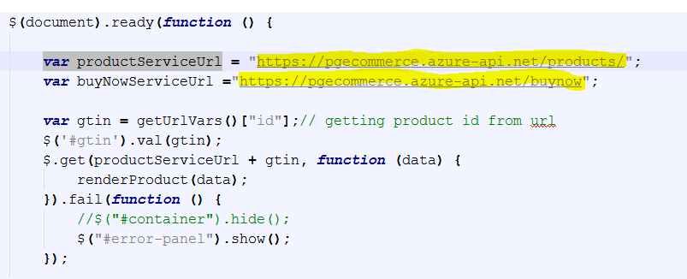
3. Change ***productServiceUrl*** value to pgecommerce product API that you configured in API management in earlier exercise.
4. Also change ***buyNowServiceUrl*** value to Buy Now API you configured
5. Save the changes
6. Now open the product listing page “show-products.html” in web browser. Click on product title / show details link of any of product. You should see product details loaded.

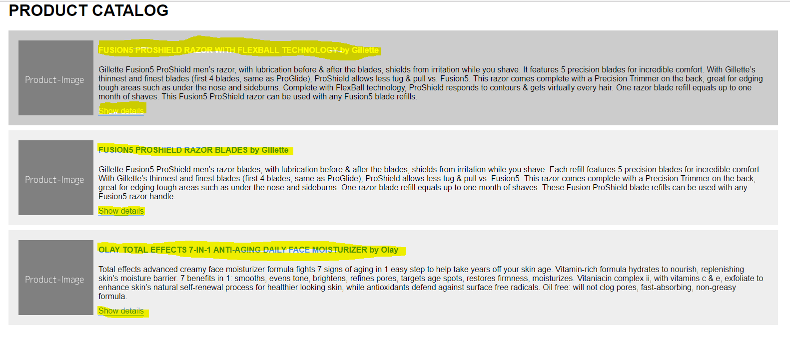

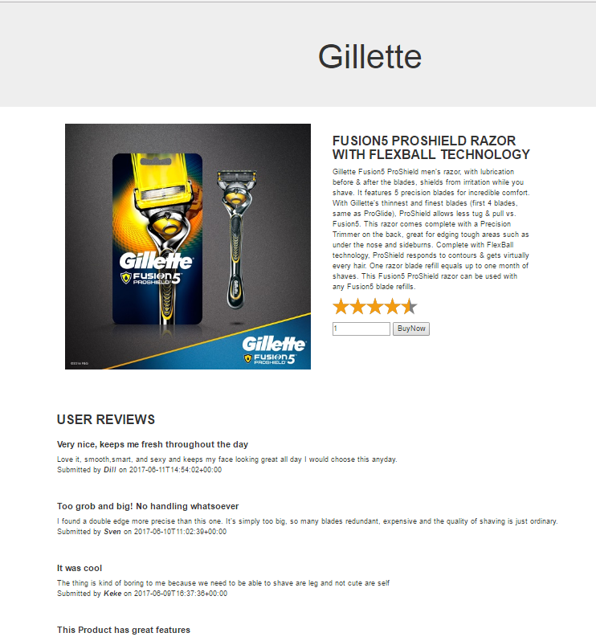

## Order Listing page

Order listing page show list of current orders by making call to Order API you configured in earlier exercise. Follow below steps to config page in local machine: -

1. Open ***orders.html*** page in Notepad++ / Visual Studio
2. Search for “**var productOrderServiceUrl**”. You will find variable declaration as shown in below image: -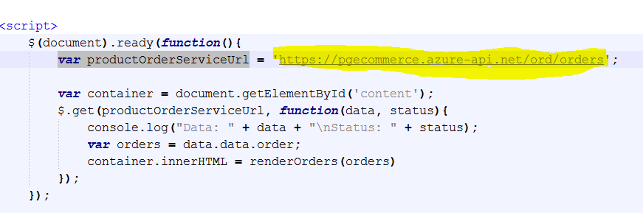
3. Change productOrderServiceUrl value to Order API that you configured in API management in earlier exercise.
4. Save the changes
5. Now open the orders.html in web browser. You should see orders listed if any.

